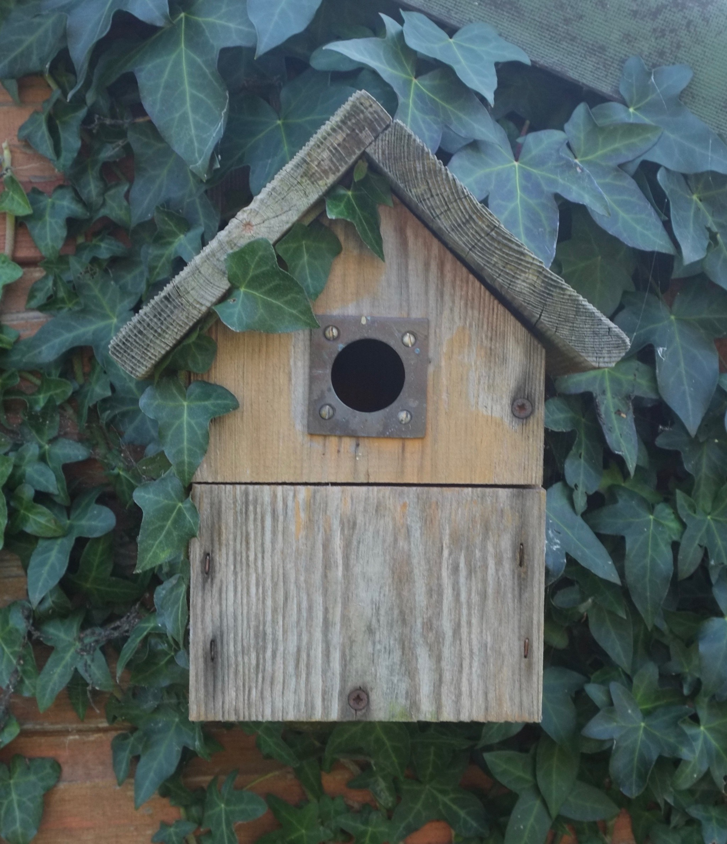

Variety, they say, is the spice of life. In fact, variation in the natural environment (or biodiversity as it is known) is essential to the health of the world around us. From the trees that protect animal habitats, to the insects that pollinate the plants that the animals feed upon, to the fungi that decompose organisms to produce a rich productive soil that supports those plants. These and other interconnections create a fabric that supports and maintains the natural world that we all depend upon, and damage to any one element can have serious and unexpected consequences for the whole ecosystem.

The allotment association through its biodiversity team encourages the maintenance of an allotment site that promotes a rich diverse environment of native plant and animal life. Liaising with other local groups, the team provides and maintains the bird, bat and bee boxes for the site and is an invaluable source of information on biodiversity issues relating to the allotment site and the wider area. Should any tenant wish to install any of these items on their plot, or plant wildflower seeds they can contact a member of the biodiversity team who will be only too pleased to help. The committee keeps details of the range of wildlife indigenous to the area and any unusual sightings of plants, birds, animals or reptiles should be reported to a member of the biodiversity team or any member of the allotment committee. For contact details of the allotment committee and biodiversity team, please refer to the notice boards.

