LLANDOUGH COMMUNITY COUNCIL

COMMUNITY TRANSPORT SERVICE
(A convenient way to shop and an opportunity to meet new friends)
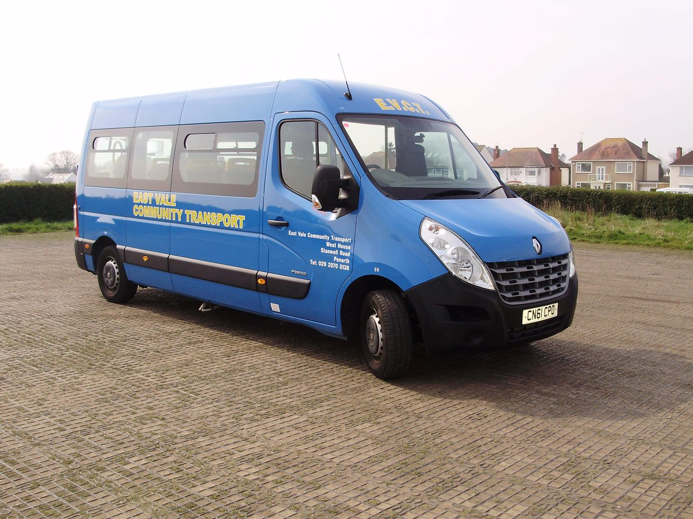

This service is available to all Llandough residents on Thursday morning each week. The bus will stop outside your home and take you to one of the local supermarkets. Our volunteer driver will assist you with your shopping and make sure that you are transported back home.

If you would like to take part in this popular scheme all you have to do is telephone Paul Egan (Clerk to the Council) on 01446 409294 with your name and home address.

