

**LLANDOUGH COMMUNITY COUNCIL**

**IN TOUCH**

**www.llandough-cc.co.uk**



We reported in the previous newsletter that the Community Council was making plans to provide a multi-use games area in the King George V Memorial Playing Fields. A recent community consultation with residents living closest to the proposed site produced a positive result with almost all those attending an event in the Hall giving support to the proposal. On this basis, the Council is moving ahead with its plan and with funding secured it is hoped that by the end of December 2019 the facility will be available for use. The MUGA as it is known will be a much welcome addition to the facilities available for younger people in the community and it is certain they will welcome the opportunity to develop their sporting skills.

**MULTI USE GAMES AREA (MUGA)**

The Llandough War Memorial Hall comprises of a large hall capable of accommodating up to 100 people, a large and well-equipped kitchen, disabled toilet facilities, baby changing facilities and rear meeting room space for up to 12 people.

The Hall has been maintained to a very high standard and is currently available for celebratory parties, meetings of groups as well as sporting and cultural activities. Hire rates are very reasonable -for occasional users the rate is £15 for the first hour and £11 per hour thereafter and for regular users a much-reduced price of £9.00 per hour. There are a limited number of weekday evening and weekend slots that are available for immediate hire.

If you are interested in making a booking, please contact Paul Egan on 01446 409294 or by e-mail [p.egan67@ntlworld.com](mailto:p.egan67@ntlworld.com)

**NEXT LITTER PICK**

The Community Council will be holding a litter pick on Saturday 27 April, 2019 from 10.00am until 12 Noon. Volunteers are invited to join councillors by arriving at the Llandough War Memorial Hall at 10.00am when litter pickers and high visibility jackets will be issued. You are advised to wear suitable footwear. Litter picks are an important method of helping improve the environment of our community and it is hoped that many of you will take part.

**COUNCIL SURGERY**

Our next Council Surgery will be held on Saturday 4 May, 2019 from 10.00am until 11.00am in the Llandough War Memorial Hall. This is an opportunity for you to share your ideas and concerns with community councillors. We look forward to seeing many of you at the surgery.

**STREET FURNITURE**

The Council arranged for benches on the village green and garden to be painted in September last year and we will also be having the benches at Brook Green painted in the next few weeks.

**MAKING USE OF YOUR COMMUNITY hall hallhalhhhhhhhhhhallhallhHALL**

**SPRING 2019**

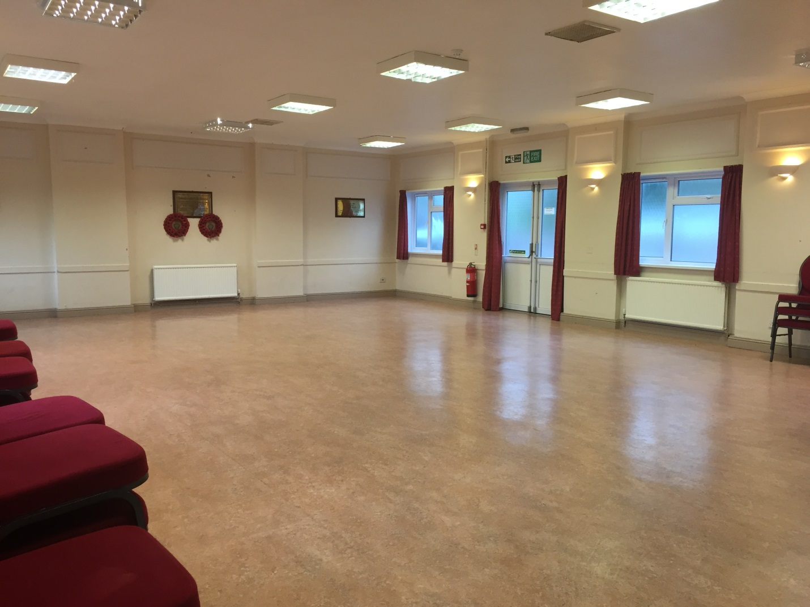

INTERIOR VIEW OF HALL

**Paul R. Egan, Clerk to the Council – Telephone 01446 49294 or e-mail: clerk@llandough-cc.co.uk**

**COUNCIL WEBSITE**

**The address for the Council’s website is** [**www.llandough-cc.co.uk**](http://www.llandough-cc.co.uk)**. Here you will find details of your Councillors, agendas and minutes of Council and Committee meetings, latest news and contact details of local groups and organisations.**

For residents who are interested in the history of Llandough the website now provides full details of all buildings of significance and a 1900 map of the Llandough. There are also a number of web-links to articles relating to the community including the findings of an archaeological excavation that found the existence of a an Early-medieval Monastic Cemetery at Llandough, in 1994.

**LLANDOUGH ROYAL BRITISH LEGION CLUB**

Situated directly behind the Llandough War Memorial Hall, the Club is very keen to attract more visitors to its lovely, friendly and welcoming establishment right in the heart of the village. Attractions apart from a sociable visit and a drink include monthly quiz (Last Saturday each month), skittles, New Year’s Eve Party and televised sporting events. It is also an ideal venue for family parties and celebrations. Why not drop by any evening for a drink and a chat and see what we can offer. New members are welcome and if you would like to know more please call Dave on 07968867409.

**DOG FOULING**

Responsible dog owners are in the majority and this message is not intended for you. However, there are a small minority of people who do not clear up dog mess and leave it there for others to tread on**. How unhealthy is that?** Everyone needs to pull together to protect the environment of our community and if anyone witnesses the actions of an irresponsible dog owner please report the matter to the Vale of Glamorgan Council - Web Link https://forms.valeofglamorgan.gov.uk/en/DogFouling

**WILDFLOWER SEEDS AND BULB PLANTING**

The Council’s Bio-Diversity Working Party have been very active in the past 6 months in planning for the next phase of the local scheme and through planting of bulbs in conjunction with local school pupils and also planting wildflower seeds on the village garden, village green and in the playing fields. You will have probably seen the product of the spring bulb planting and in the Summer period it is hoped that there will be an array of flower in our community. The Working Party is now planning to erect more bird and bat boxes and some of these will be located at the Corbett Road allotments site. It is important that all communities invest in bio-diversity and the Community Council takes very seriously the importance of maintaining bio-diversity in the community.

**THIS YEAR’S VILLAGE FETE**

The fete will be held on Saturday 8 June in the playing fields and there will be a full programme of activities and a range of stalls to keep you entertained during the afternoon. This year we are looking to extend the range of stalls that are available at the fete and any local groups or businesses based in Llandough are invited to apply to have a stall at this year’s fete. In the case of commercial businesses all we ask is a 20% contribution of takings which will help fund the fete. If your group or business wishes to be considered for a stall please contact the Clerk to the Council on 01446409294 or by e-mail- [clerk@llandough-cc.co.uk](mailto:clerk@llandough-cc.co.uk)

**ALLOTMENTS**

Allotments became the vogue during and after the 1st World War and today they remain in demand for local food production, exercise and building up of new friendships. Your community council operates a large allotments site off Corbett Road and now is the time to consider adding your name to the waiting list for a plot. The first-year rental is around £38 with reductions for senior citizens and if you are interested please contact the Clerk on 01446 409294 or e-mail [clerk@llandough-cc.co.uk](mailto:clerk@llandough-cc.co.uk)

**CIVIC SERVICE**

This year’s Civic Service will be held on Sunday 16 June, 2019 at 3.00pm in St Dochdwy’s Church. All residents are invited to attend to celebrate the installation of the new Chairman of the Council. Councillors Pam Gay and Elliot Penn have been appointed as Chairman and Vice Chairman Elect respectively for 2019/20.

**IN TOUCH**

**Paul R. Egan, Clerk to the Council – Telephone 01446 409294 or e-mail****clerk@llandough-cc.co.uk**

**PLANNING APPLICATION FOR APARTMENTS ON LAND NORTH OF LECKWITH ROAD**

Your Community Council strongly objected to the planning application but it was approved with conditions by the Vale of Glamorgan Council’s Planning Committee on 28 March, 2019. The Chairman of the Council Councillor Pat Carreyett attended the Committee’s site visit and Councillor Lucy Barrowclough spoke against the application at the Planning Committee meeting. The Council’s objections were as follows: -

1. The proposal represents a significant over-development on a restricted site and the apartment density remains far too high for the location. Although acknowledging that the number of apartments has reduced from 50 to 40 it remains the strong view of the Council that this number is far in excess of what would be appropriate for this site.
2. The proposal is unneighbourly and would not fit in with the general environment of the adjoining area and the visual impact would be a major issue in terms of the environment of the area as well as having an undesirable impact on the privacy of neighbouring occupiers.
3. The local development plan had identified this site as suitable for 8 dwellings and the Council considers that this would represent an appropriate form of development on the site. The departure from the LDP is totally unacceptable.
4. It is understood that there might be existing drainage restrictions relating to the site which could impact on the development and possibly have an adverse impact on the adjoining properties. It is understood that some residents in Leckwith Road had jointly funded an enhancement to the drainage system and they are rightly concerned about the impact of such a development on their properties.
5. There is insufficient parking and amenity space identified in the proposal.
6. The scale and size of the proposed development is far too great and overbearing and is totally unsuitable for this location.
7. There are no facilities in Llandough to provide for the needs of a large influx of people. For example, there are no local shops and no GP facility. Furthermore, local bus services have already been cut and it is understood that there are plans afoot for the 95a and 95b services to be reduced with a possibility that Penarth will not feature in their destination itinerary.
8. There would be a major issue for highway safety as a result of the number of vehicles accessing Leckwith Road from within the development. Furthermore, the number of cars right turning and entering the site may produce a tailback situation which would exacerbate traffic movement on Penlan and Leckwith Road. It should be acknowledged that Leckwith Road serves Llandough Hospital which is the second largest hospital in Wales and there are plans to expand the range of services such as the transfer of the Rookwood hospital complex.
9. The Council would wish to point out that a proposed flats development in the near vicinity of the site at Keepers Gardens was refused on 13 November, 2003 (Application No.2002/01503). This related to a proposal for 21 flats which would have been set back well off the road. The decision on 13 November, 2003 was to refuse the application.

|  |
| --- |
|  |
| Although planning policy and plans have changed since 2003, it is the view of the Council that the reasons for the refusal of this application are equally applicable to the current proposal.  j) The proposed design of the blocks of flats is very unattractive and substantial improvements to the design should be considered as well as a major reduction in site density in line with the local development plan. It is important that the design blends in with those properties on Leckwith Road visible from the main road.  k) The storage on the proposed site of up to 80 black refuse bags during a 2-week period is of concern to neighbouring occupiers especially during periods of warmer weather. |  |

If approved, it is considered that the developer should be required to contribute significant S106 funding to address transport infrastructure issues including the provision of a new bus stop and shelter facility as well as investment in issues relating to safe access to the school.

The conditions to be met by the developer can be viewed on the following web-link:- <https://www.valeofglamorgan.gov.uk/Documents/Living/Planning/Committee/2019/Planning-Committee-Agenda-28-March-2019.pdf> (Note – In view of the nature of the development, S106 funding is not appropriate)

**IN TOUCH**

Paul R. Egan, Clerk to the Council – Telephone 01446 409294 or e-mail: clerk@llandough-cc.co.uk

LLANDOUGH NEXTDOOR SOCIAL MEDIA SITE

There are currently around 386 residents signed up to this relatively new site that provides the opportunity for all of us to keep in touch, share news stories and seek advice from each other. This is a great way to keep in touch with neighbours and friends and with your Community Council – the weblink is https://nextdoor.co.uk/neighborhood_feed/

**DID YOU KNOW THAT….**

Zumba, martial arts, dance and Pilates groups hold sessions in the Hall every week. There is also a long-standing Thursday Club that operates from the Hall. If you would like to join up please e-mail the Clerk who will provide you with their contact details.

**Llandough Rainbows and Brownies need your help**

Unfortunately, the units were unable to open after the summer break. There is currently no Girlguiding at all in Llandough which means that girls aged 5 to 14 are missing out on so much. We need adult volunteers to help run the units with full support and training. If you think you could help you can find out more by contacting Judith on 07765513424 or email her at commissionerseg@gmail.com

**SCOUTING IN LLANDOUGH**   
Aged 18 or over? Do you want to experience regular adventures? Need a fresh challenge? Want to meet new people?  
   
Penarth and District need extra adult volunteers to help support the running of the 1st Llandough Scout Group. From this term the Beaver colony was put on hold due to low leader numbers, leaving just the Cub pack meeting weekly on Mondays. It’s vital to have strong adult support for 1st Llandough Scout Group, to grow to a thriving and key environment for the young people of the community to gain skills for life. There’s also a plan to develop the hall, located off Lewis Road.    
**Come and be a part in the resurgence of your local Scout Group!**   
As an adult volunteer you get to be involved in all activities, trips and camps run. You gain new experiences that look great on your CV or can be used as evidence of personal development. The DBS process and all training offered by The Scout Association, which is recognised by the Institute of Leadership and Management (ILM), comes at no cost to you.    
Any time commitment you or someone you may know can give, a role can be found to suit!  
Urgent roles required filling:  
Assistant Beaver Leader   
Group Scout Leader (aka Group Manager)  
 For further information or to show your interest, please contact Carl Rogers: [carl@penarthanddistrict.org.uk](mailto:carl@penarthanddistrict.org.uk)

**st. dochdwy’s church pre-school play group**

Llandough TOTs is a get together for those with pre-school children on Wednesday mornings during school term time. Held at Llandough War Memorial Hall, from 9.15am to 11.15am, you are welcome for tea/coffee and toast at a moderate cost of £1.50. Come and meet other mothers, fathers and grandparents with their children. You and your children would be most welcome. Some really good news is that the Group has received a grant for new play equipment from the Welsh Government.

**COMMUNITY TRANSPORT SCHEME**

The Council operates a community transport scheme for the benefit of local residents who wish to visit to local supermarkets. The service operated by Paul Morris, a local resident, is available on Thursday mornings and anyone interested in accessing the service should contact the Clerk to the Council. We want to hear from anyone who would benefit from taking part in the scheme. As well as providing access to the supermarkets it is an opportunity for those involved to make new friends.

**NEW PARK BENCH ON COGAN PILL ROAD**

The Council will be funding a new park bench located on Cogan Pill Road near to the bottom of the slide and we hope that parents will appreciate the opportunity to sit down whilst supervising their children using the play equipment.

ROGATION WALK

On Thursday 23 May the Council will be organising a Rogation Walk involving Reverend Mark Jones and pupils and teachers from Llandough Primary School. Rogation walks bring together sections of the Llandough community with a focus on nature, showing the participants the beauty of our community, teaches a little about history and local tradition and is a lot of fun for those involved.

IN TOUCH

IN

D

**kkk**

If you have any ideas or suggestions you would like the Community Council to consider please feel free to write to the Clerk to the Council, 63 Woodham Park, Barry CF62 8FJ or e-mail him on clerk@llandough-cc.co.uk