LLANDOUGH COMMUNITY COUNCIL
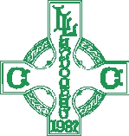
ANNUAL CIVIC SERVICE

Councillor Dr Mo Misra warmly invites all residents to attend the Annual Civic Service.

📅 Sunday 31 May 2026
🕒 3:00pm
📍 St Dochdwy’s Church

Refreshments will be served afterwards at Llandough War Memorial Hall.

We hope you can join us for this special community occasion and look forward to welcoming you.

