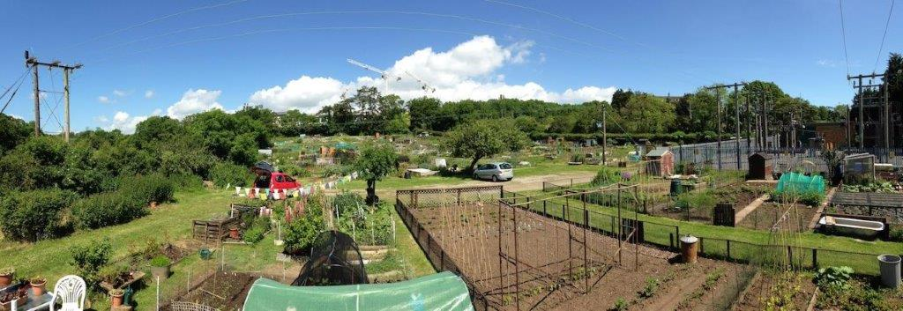
Welcome to Corbett Road Allotments…
We are a small and friendly site with 69 plots, some of our plot holders have been working their plots for many years (25-30 years!) and many are new to allotment life. Encouragement and advice is always on hand!
Taking on a new plot often involves taking on a plot that has not been worked for a while which could mean plenty of weeds (couch grass/bindweed/ground elder) and some heavy digging. Depending where your plot is will determine how heavy – most of the site is on a clay base which means heavy soil and poor drainage, although both are improved hugely by the addition of plenty of mature compost/manure – and digging unless you embrace the “no-dig” philosophy. For “no dig” to work well the plot must be clear of invasive weeds first. Rome wasn’t built in a day… persistence pays off!
The Tenants Association has a committee of up to six plot holders (elected annually at the AGM) to represent the membership, and who are involved with the day to day running of the site. A list of committee members with plot numbers and phone/email for the Chair, Secretary and Treasurer is displayed on the notice boards.
The committee meets monthly and minutes are posted on both notice board, circulated by email if you have provided that to the Secretary; hard copies are delivered to the sheds/greenhouse to those who do not have email. The committee discusses any issues that have arisen/site security /ground works/hedges and ditches etc. and carries out a site inspection at each meeting to flag up any issues, and to identify plots requiring a bit more attention.
The committee meets with the Llandough Community Council Working Party on a quarterly basis and discuss any issues we may have/ respond to requests from the Association etc. The secretary of the Tenant’s Association is in frequent contact with the Clerk to the Council between meetings.
Notice board – the noticeboard is in the main/lower car park for Association communications, minutes, notices etc. There is also a board in the lower car park where notices can be posted with, for instance, tools for sale/plants to swap etc.

Email / GDPR – If you have provided the secretary with your email address / address or phone number these will only be used for the secretary to contact you with news and events.
If you would like to view the contact information the Association holds about you, it will be sent to you upon request. You have the right to ask us to remove any or all of it at any time, and if you do so it will be permanently deleted from our records. You may do this by contacting the Secretary of the Association verbally, phone or email. The information we hold about you will never be used for any marketing purpose, or passed on to any other person or organization without your permission. As a member of the association you have responsibilities under the General Data Protection Regulations and you should not make public or disclose to people or organizations who are not members of the association anything you receive.
Meetings for tenants - We have two meetings p/a to which all tenants are invited – the AGM (Sept/October) and a Spring Meeting (March).
Hedges and paths – Which path is your responsibility?
All plot holders are responsible for the path on the left-hand side of the plot as viewed from the main/central path. These should be strimmed/mown regularly.
On the main part of the site (above the lower car park) the front plot holder is responsible for the path behind their plot, the rear plot holder is responsible for keeping the hedge trimmed and the ditch clear where there is one. The main path and other common areas are cut by Council contractors.
Paths which aren’t cut regularly present a real hazard for everyone, especially those accessing plots at the hedge ends of the site.
Improvement notices A tenant whose plot needs an improvement communication will initially receive an email from the Secretary (assuming he has your email address or from the Clerk if he doesn’t), and if no or insufficient action has been taken after 2-4 weeks to improve the state of the plot follow up communications will be from the Clerk to the Community Council requesting significant improvement within 2 further weeks. If insufficient/no improvement is made the decision to terminate a tenancy will be taken by the Community Council.
We appreciate that “life” (ill health/family situations/work and holidays) often get in the way of good intentions to keep your plot cultivated so, if you are struggling with your plot please contact a member of the committee and let us know – maybe we can help, or at least avoid sending an improvement letter where it is not appropriate.
Uncultivated / unworked plots can become overgrown with weeds and brambles very quickly – these often seed on to neighbouring plots causing no end of grief and bad feeling! The smothering of weeds with black membrane often helps to control the problem for a while. It is also important to keep your plot free from tyres/plastic/etc. to avoid a “Steptoe’s Yard” situation! Whatever – should you give up your plot we will require you to clear the plot of “rubbish” before you terminate your tenancy.
It is certainly the case that plots that are cleared in the autumn with some preparation and digging are much more productive and easier to manage than those that are ignored through the late autumn/winter!
Cultivation Guidelines These are produced so that members know what the committee look for during plot inspections which take place at each monthly committee meeting.
Security - Gate/keys Site security is important! Please lock the gate if you are the last to leave. It is also important to be aware of anything untoward which might for instance indicate a break in to sheds and report it to any member of the committee.
Police/Emergency Services A notice displaying a phone number for our local Community Police contact is displayed on the noticeboard in the main car park.
In an emergency, you should always call 999. The postcode for the site is CF64 2QX
also
What.3.words is an app which you can download to your phone – this will identify to emergency services exactly where you are within 3 metres – anywhere.
Read about it on: www.what3words.com
A site plan has been prepared identifying each plot and will be posted on the notice board – look up your plot – either on the app or on the notice board. What3Words is recognised by emergency services.

Water – there are taps and baths situated up the main paths. The water is turned off in winter, usually in late October and turned on again in the Spring – so you’ll need to remember to bring water for your cuppa if you like to “have a brew” in your shed in the winter!
The use of hand held hosepipes is permitted during the Spring/Summer; sprinklers or similar are a definite “No”!
We encourage plot holders to adopt water saving measures by installing rainwater goods and water butts on their sheds and greenhouses.
Bonfires - Bonfires are permitted for the burning of weeds and wood, and the Bonfire Rules are displayed on both noticeboards – showing which plots can / can’t have a bonfire on their plots. Anyone wishing to light a bonfire should first be aware of wind direction and weather conditions and also the proximity of neighbouring plot holders and properties (houses in Corbett Road and Llandough Hospital). If you are asked to extinguish a bonfire by someone with a health condition please do so without question.
The “Fire Skip” located at the end of the lower car park is available to anyone wishing to burn wood / weeds, in particular plots at the top of the site below the hospital where bonfires are not permitted. There is a fire hose/bath adjacent to the shed on plot 56 for use if necessary. Please note – the skip is not for dumping rubbish…
All bonfires must be attended, and extinguished before you leave the site.
Please…avoid burning plastic … take it and any other rubbish to the recycling depot or home!
It is really important that everyone sticks to the rules – any complaints from neighbours about smoke will result in an immediate and total ban on bonfires from the Community Council.
Sheds / greenhouses and polytunnels - permission to erect any of these should be sought from the Community Council by supplying a plan / sizes etc. Details in tenancy agreement.
Tenancy Agreement – most of the nitty gritty regarding your tenancy is in the agreement – which you will have signed when you took on your plot. There are occasionally updates/amendments through the year and these are reported in the minutes. As a member of the Association who has signed an agreement the updated clauses will apply to all.
First Aid – Tenants are advised to keep a first aid box handy for their own use.

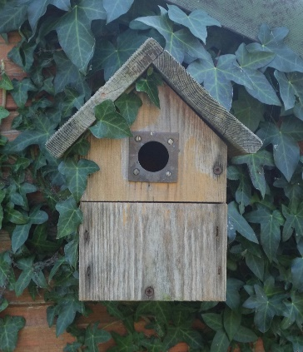
Biodiversity
Variety, they say, is the spice of life. In fact, variation in the natural environment (or biodiversity as it is known) is essential to the health of the world around us. From the trees that protect animal habitats, to the insects that pollinate the plants that the animals feed upon, to the fungi that decompose organisms to produce a rich productive soil that supports those plants. These and other interconnections create a fabric that supports and maintains the natural world that we all depend upon, and damage to any one element can have serious and unexpected consequences for the whole ecosystem.

The allotment association encourages the maintenance of an allotment site that promotes a rich diverse environment of native plant and animal life.

The Community Council has a duty under Section 6 of the Environment (Wales) Act 2016 to enhance the biodiversity of its community and any measures it takes in pursuance of this duty must be closely monitored and corrective action taken as appropriate. Accordingly, it will be necessary from time to time for your plot to be inspected for the purpose of assessing biodiversity measures that have been taken and where appropriate corrective action taken to address any issues identified (e.g. repair of damaged bird box).
Social – We usually hold a coffee morning on site after one of our committee meetings in the Spring; and one or two summer barbeques. How about a seed swap? Any suggestions for social events would be welcomed! If you would like to organize something – even better - please let the committee know!
We are always looking for people to help with jobs around the site, and of course to stand for Committee.
Llandough Annual Fete - We have a stall at the Llandough Fete usually held in the early part of June. The success of this as a shop window for our site and a fund raiser depends on contributions of produce and plants and help on the day. Popular this year were rhubarb, broad beans, decent sized tomato plants, chilli plants, dwarf bean plants, brassica plants and established herbs. Most of the people who buy things are not allotmenteers but people who want things to eat, or grow on their patios/small gardens – so we would encourage plot holders to plan ahead when sowing seeds in the early part of the year!

Surplus Produce – Andrea (Plot 59) works with refugees and has offered to distribute surplus produce. This should be left in the silver bin adjacent to the lower car park next to the fire skip. Please phone Andrea (whose number is on the notice board) to alert her that you will be leaving produce for her to collect
Llandough Diggers…. Facebook – We have facebook group – let us know if you would like to join!

Manure – there are two local sources of manure. Downside Stables (next to Brynawel Garden Centre on Sully Road) – will deliver “fresh” manure which will take approx. 1 year to be usable. Phone Caz at Downside on: 07717 662814
Erw Delyn Stables (Sully Road) NO LONGER have a large mature manure pile. We are currently investigating making some silos for a delivery of fresh manure from Erw Delyn.
Local garden centres – the closest is Brynawel Garden Centre (Sully Road); also Pugh’s near Wenvoe.
Wilkos/B&M etc often have bargains on seeds!
The National Allotment Society
(National Society of Allotment and Leisure Gardeners Ltd).
https://www.nsalg.org.uk

Excerpt from their “Mission” Statement
“The National Allotment Society (NSALG) is the leading national organisation upholding the interests and rights of the allotment community across the UK. We work with government at national and local levels, other organisations and landlords to provide, promote and preserve allotments for all. We offer support, guidance and advice to our members and those with an interest in allotment gardening.
In 2011, His Royal Highness the Prince of Wales kindly agreed to become the Patron of the Society. The Prince is an avid gardener himself and advocate of green issues, he is also keen to promote and protect the UK's enduring traditions.”

There are many benefits to being a member of NSALG – including discounted prices from Kings Seeds; Public Liability Insurance. They produce a quarterly magazine – always very interesting.

Happy Gardening!

Draft 10 . Amended CC . 1 March 2020

