To Members of the Policy and Resources Committee

6 February 2021

Dear Member,

MEETING OF THE POLICY AND RESOURCES COMMITTEE

The next meeting of the Committee will be held on Monday 15 February, 2021 at 7.00pm. It will be held on a remote basis in accordance with the provisions of the Local Authorities (Coronavirus) (Meetings) (Wales) Regulations 2020. An invitation will be sent to you providing the link for you to join the meeting.

The agenda will be as follows: -

- To receive apologies for absence.
- To receive declarations of personal and prejudicial interest.
- To confirm the minutes of the meeting held on 19 October 2020 (Attached).
- Matters Arising from the Minutes.
- To receive the income and expenditure accounts at 31 January 2021 (Attached).
- To consider a verbal report from the Clerk in relation to the projected end of year reserves.
7. Any other business at the discretion of the Chairman.

Yours faithfully,

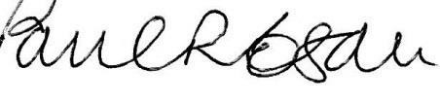
Paul R. Egan
Clerk to the Council
MEMBERS OF THE PUBLIC MAY REQUEST PAPERS AVAILABLE FOR THIS MEETING AND CAN JOIN THE REMOTE MEETING BY CONTACTING THE CLERK FOR JOINING DETAILS.

