To Members of the Policy and Resources Committee

`14 June 2026

Dear Member,

MEETING OF THE POLICY AND RESOURCES COMMITTEE

The next meeting of the Committee will be held remotely on Monday 22 June 2026 at 7.00pm.

The agenda will be as follows: -

- To receive apologies for absence.
- To receive declarations of personal and prejudicial interest.
- To confirm the minutes of the meeting held on 9 February 2026 (Attached).
- Matters Arising from the Minutes.
- To receive the income and expenditure accounts at 31 May 2026 (Attached).
- To consider the adoption of a car mileage rate of 55 pence per mile as confirmed by the HMRC as the new tax-free rate from 1st April 2026.
- To agree on the timing for the first meeting of the Community Plan Working Party involving declared third parties.
- Any other business at the discretion of the Chair.

Yours faithfully,
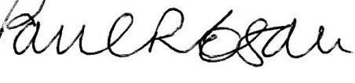
Paul R. Egan
Clerk to the Council
MEMBERS OF THE PUBLIC MAY REQUEST PAPERS AVAILABLE FOR THIS MEETING AND CAN JOIN THE REMOTE MEETING BY CONTACTING THE CLERK FOR JOINING DETAILS. clerk@llandough-cc.co.uk or 01446 409294

