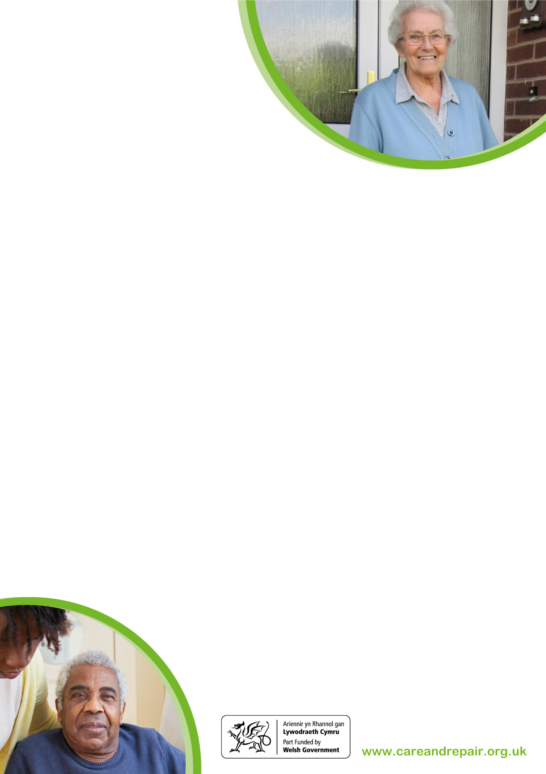­

Helpwyd 116 o bobl i ymgeisio am grantiau gwerth **£45,475**

**Am wybodaeth ac i Gyfeirio Achosion**

Mae ein rhifau ffôn diweddaraf isod

**029 20473337 - Ymholiadau Cyffredinol**

**029 20467345 - Achosion Cyfeirio RRAP Caerdydd**

**029 22401308 - Achosion Cyfeirio RRAP y Fro**

careandrepair@crcv.org.uk

gwneud eu cartrefi'n ddiogel a sicr

**Gwasanaeth Gwybodaeth a Chyngor**

* Cyngor ar atal cwympiadau a gosod eitemau diogelwch bach fel canllawiau cydio, canllawiau grisiau a sêffs allweddi
* Darparu manylion contractwyr dibynadwy i gleientiaid gysylltu â nhw am ddyfynbrisiau
* Gwybodaeth am wasanaethau lleol eraill sy'n cynnig help perthnasol

**Gwaith Achosion & Gwasanaethau Technegol**

* Cyngor ar atgyweiriadau, addasiadau a gwaith cynnal a chadw yn y cartref
* Cyngor ar grantiau a chyllid lles i dalu am waith
* Gall Swyddogion Technegol ymweld â chleientiaid i drafod y mater, archwilio'r eiddo a helpu i flaenoriaethau'r gwaith sydd i'w gwblhau
* Gall Swyddogion Technegol hefyd lunio manylebau ar gyfer gwaith a threfnu dyfynbrisiau, contractau a goruchwylio gwaith ymarferol sy'n cael ei gwblhau ar y cartref
* Gall gweithwyr achosion ddarparu gwresogyddion brys dros dro am ddim a phecynnau gwresogi'r gaeaf pan fydd systemau gwresogi'n stopio gweithio
* Cymorth a chyngor i helpu i gadw'n gynnes, arbed ynni a thalu biliau tanwydd.

Elusen ydyn ni sydd â'r genhadaeth o helpu pobl hŷn i atgyweirio, addasu a chynnal a chadw eu cartrefi.

Ein gweledigaeth ni yw bod pob person hŷn yn gallu byw mewn cartref diogel, sicr, cynnes a chyfforddus sy'n addas iddyn nhw a'u bywydau tra'n mwyhau eu hannibyniaeth.

Mae ein grŵp cleientiaid dros 60 oed, yn byw yn eu cartrefi eu hunain neu'n rhenu cartrefi preifat.

**Ein Gwasanaethau**

Mae gennym dîm profiadol sy'n cynnwys Swyddogion Gwybodaeth a Chyngor, Gweithwyr Achosion a Swyddogion Technegol. Rydyn ni'n cynnig cyngor a chymorth dros y ffôn, drwy e-bost ac yn y cartref.

Rydyn ni'n gwrando ar ddymuniadau ac anghenion cleientiaid i greu pecyn cymorth wedi'i deilwra.

**Dod i Ben yn Well**

Rydyn ni'n rhoi cyngor i gleientiaid sydd â nam ar eu golwg neu eu clyw, dementia neu sydd wedi cael strôc. Rydyn ni'n asesu'n cartref, yn darparu cyngor ac yn cynnig offer arbenigol i alluogi cleientiaid i *ddod i ben yn well* gartref.

**Rhaglen Addasiadau Ymateb Buan (RRAP)**

Gosod eitemau diogelwch bach fel canllawiau cydio, canllawiau grisiau a sêffs allweddi i gadw cleientiaid yn ddiogel gartref neu i allu dychwelyd o'r ysbyty.

**Pwy ydyn ni**

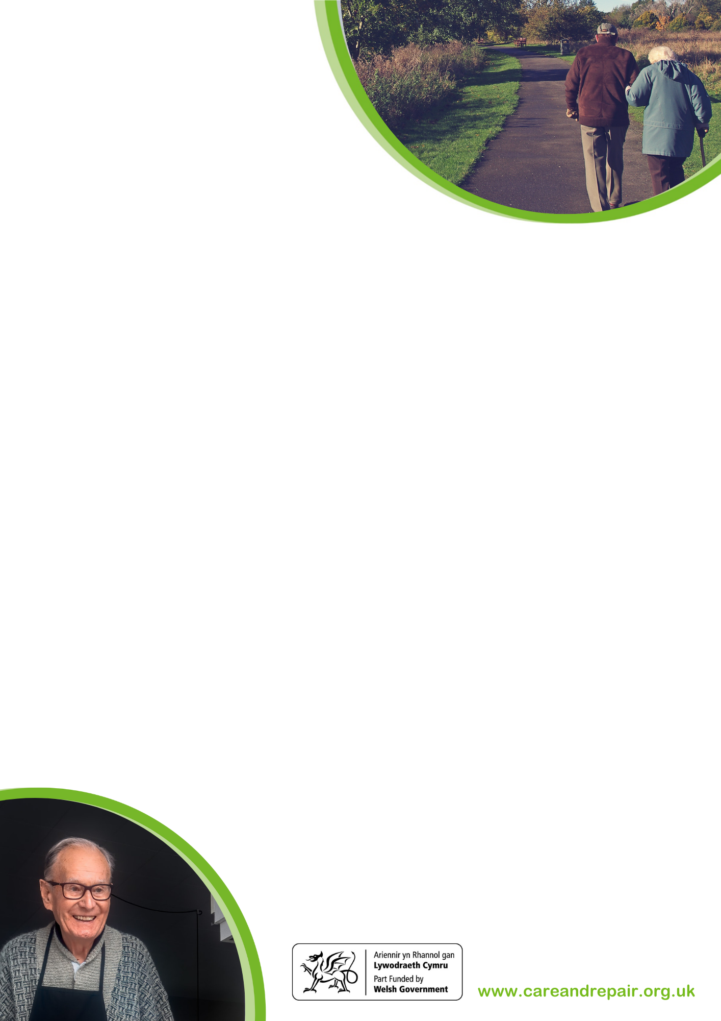­

**For Information and Referral Making**

**029 20473337 - General Enquiries**

**029 20467345 - RRAP Referrals for Cardiff**

**029 22401308 - RRAP Referrals for The Vale**

careandrepair@crcv.org.uk

**Information and Advice Service**

* Advice on falls prevention and fitting of small safety items such as grabrails, stair rails and key safes
* Providing details of reputable contractors’ clients may wish to contact for quotes
* Information on other local services that offer relevant help

**Casework & Technical Services**

* Advice on repairs, adaptations and maintenance of the home including
* Advice on grants and benevolent funding to pay for works.
* Technical Officers can visit clients to discuss the issue, inspect the property and help to prioritise the works to be completed.
* Technical Officers can also draw up specifications for work and arrange quotations, contracts and oversee practical works completed on the home.
* Caseworkers can provide free temporary emergency heaters and winter warm packs when heating breaks down.
* Support and advice to help stay warm, save energy and paying fuel bills.

**Who are we**

We are a charity with a mission to help older people to repair, adapt and maintain their homes.

Our vision is that all older people are able to live in safe, secure, warm and comfortable homes which suit them and their lives while maximising their independence.

Our client group are over 60, live in their own homes or privately rent.

**Our Services**

We have an experienced team that include Information & Advice Officers, Caseworkers and Technical Officers. We offer advice and support over the phone, email and at home.

We listen to clients’ wants and needs to create a tailor-made package of support.

**Managing Better**

We give advice to clients who are sight impaired or hard of hearing, have dementia or had a stroke. We assess the home, provide advice, and offer specialist equipment to enable clients to *manage better* at home.

**Rapid Response Adaptation Programme (RRAP)**

The fitting of small safety items such as grab rails, stair rails and key safes to keep clients safe at home or return home from hospital.