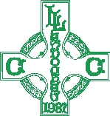

**Llandough Community Council**

**COMMUNITY TRANSPORT SERVICE**

**Do you need help with transport to do your weekly shopping at one of the nearby supermarkets?**

**Teaming up with East Vale Community Transport we will be arranging a weekly service on Thursday morning each week starting on Thursday 10 July 2025. You will be picked up from your home, have help with carrying your shopping and will be transported back home.**

**You will be requested to make a donation of £2.00 towards the cost of the service.**

**If you are interested in becoming a regular passenger please contact Paul Egan, Clerk to the Council on 01446 409294 or email him –** [**clerk@llandough-cc.co.uk**](mailto:clerk@llandough-cc.co.uk) **You need to provide him with your name, address and telephone number.**

