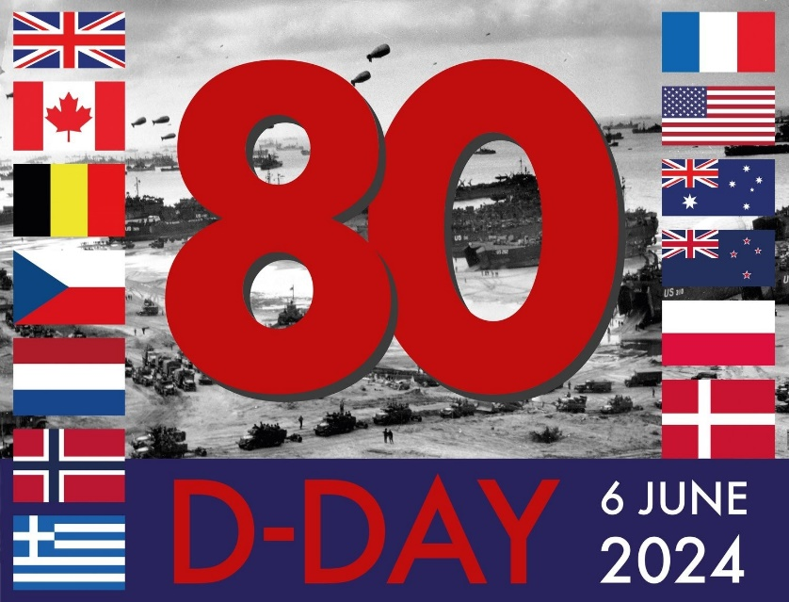

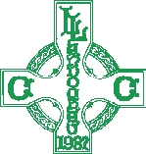

**LLANDOUGH COMMUNITY COUNCIL**

**LOCAL COMMEMORATION – D-DAY 80**

**On this important day residents are encouraged to participate in our commemoration of D-Day 80. On Thursday 6 June 2024 residents are asked to meet at the Llandough War Memorial Hall by 8.45pm when we will proceed to the playing fields led by an accomplished bagpiper. The beacon lighting will take place at 9.10pm followed by the reading of tributes.**

**The Legion Club will be open to welcome residents for a drink and a chat afterwards**