

**LLANDOUGH COMMUNITY COUNCIL**

**LITTER PICK**

**SATURDAY 14 JUNE 2025 FROM 10.00am to 12 noon**

**ALL TO MEET OUTSIDE THE LLANDOUGH WAR MEMORIAL HALL**

**Residents are invited to join Councillors in helping tidy up our community and improve the environment for everyone. High visibility jackets, litter pickers and gloves will be provided.**

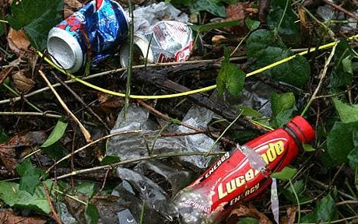

**THOSE TAKING PART SHOULD WEAR APPROPRIATE FOOTWEAR**

**Please e-mail the Clerk if you intend taking part – clerk@llandough-cc.co.uk**